Lab 5
In this lab, you’ll continue working on the program you wrote in lab 4, to practice inheritance and polymorphism.
- You'll create new classes and make changes to the classes Cat and AnimalShelter.
- An object of the class AnimalShelter is being created in your main program. One cat is already being added (Garfield).

Step 1

Parent class: Animal
- You'll create a class Animal that has the following methods:
  - __init__(self, name, gender)
  - eat(self)
  - nap(self, minutes)
  - play(self, minutes)
  - speak(self)
- The class Animal must be an abstract class.
- Make the method "speak" an abstract method. This is the only abstract method.
- The method __init__ will initialize only the name, gender, hunger, and energy instance variables. These are the only attributes that all animals will have.
- The methods eat, nap, and play will have the same code they had in previous labs (simply move these methods from the class Cat to the class Animal).

Step 2

Child classes: different types of pets
- The Animal class will be a parent class to 3 child classes: Cat, Dog, and Fish.
- The Cat and Dog classes must implement the method __init__(self, name, gender, breed, age).
  - This method must initialize breed and age and call the parent’s __init__ to initialize the other variables.
  - Fish do not have breed and age, therefore this class does not need its own __init__.
- Each of the child classes must override the speak method: cats say meow, dogs say woof, fish say glub.
  - In the class Cat, simply rename the meow() method to speak().
  - This method displays the message in the shell.
- Each child class must also have their own show(self) method, that returns a description of the animal, including the type of animal.
- The child classes do not need to override the other methods (eat, nap, and play), which are implemented in Animal (and are common to all children of Animal).

Step 3

AnimalShelter Class
- AnimalShelter is still a collection of animals. It will continue to have a single dictionary of all animals, regardless of type.
- The UI now has radio buttons for the different types of animals. You'll need to add the animal to the AnimalShelter according to the selected animal type.
  - The method add must now include a parameter pet_type:
    - add(self, name, gender, breed, age, pet_type)
    - This method will instantiate an object of either Cat, Dog, or Fish, depending on the pet_type.
- You'll continue to call oAnimalShelter.display_all() to display information for all animals in the python shell (not in the GUI window).
  - This will allow you to verify that the Add and Feed All buttons are correctly updating the animals in the shelter.
- Add a method feed_all to make all the animals "eat" whenever the Feed All button is clicked.
- Add a method speak_all to make all the animals "speak" whenever the Speak to All button is clicked.

Step 4

UI Elements
- Add the new UI elements to the window as seen in the images below.
- You may choose your own colors and widget placement.
- When the Fish radio button is selected, the Breed and Age labels and textboxes must be hidden.
  - Make sure your validation ignores these fields when adding new fish.
  - Remember to make the fields visible again whenever Cat or Dog is selected.
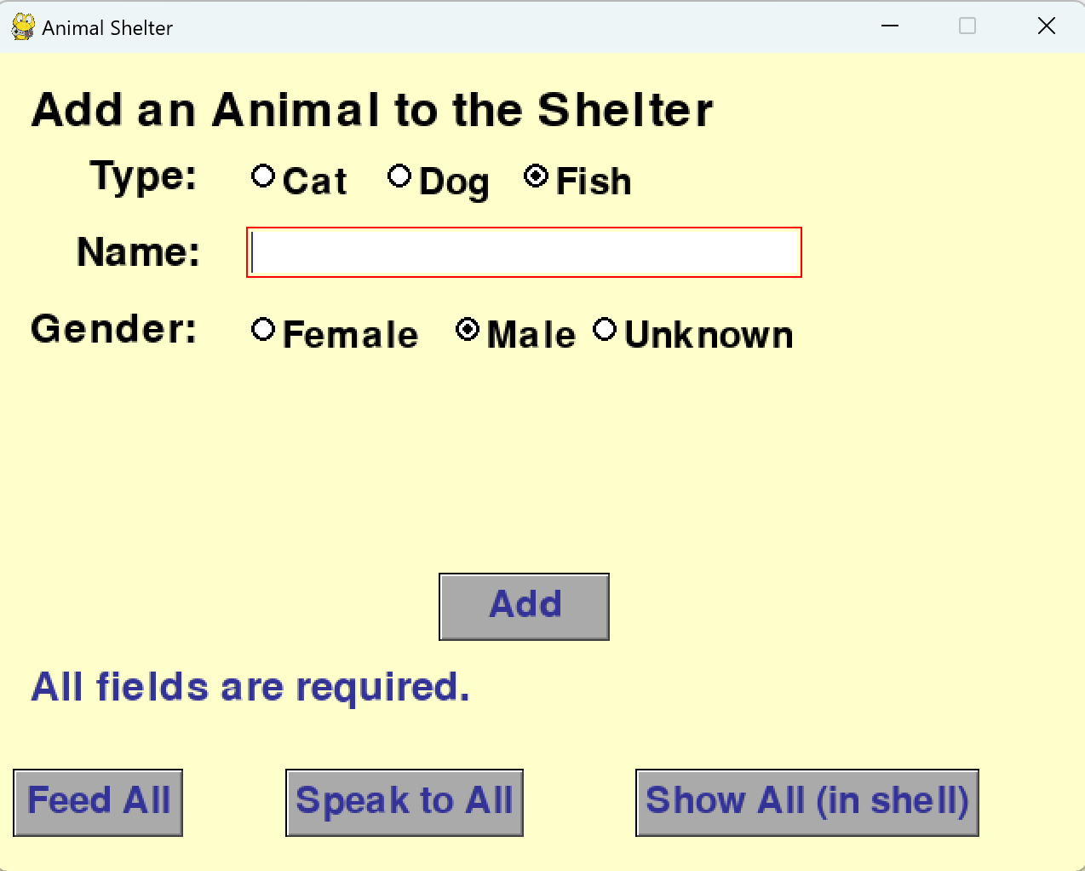
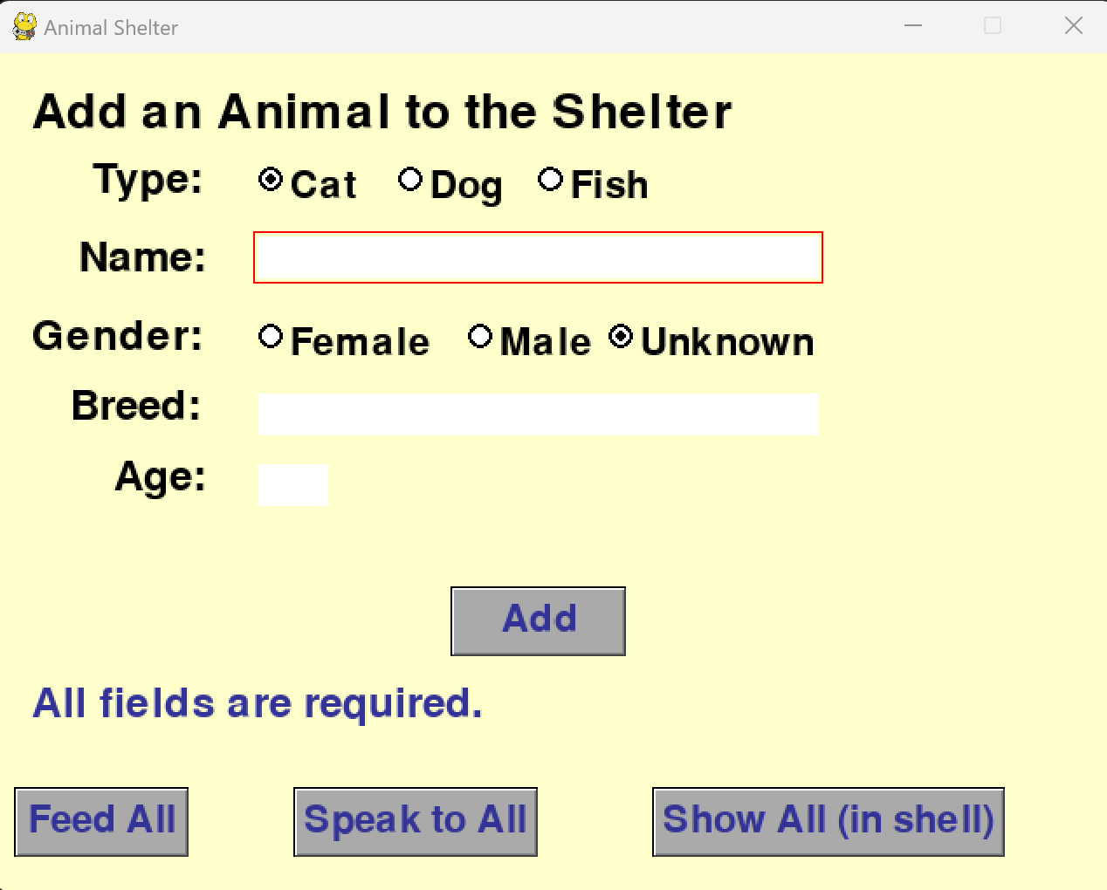
- This is the new user interface:

Step 5

Submit your program on Canvas.
- All code should be in the same file, named lab5.py
- Don’t forget to test your code and add comments.

Sample Cat and AnimalShelter classes (from lab 4)
class Cat():
def __init__(self, name, gender, breed, age):
self.name = name
self.gender = gender
self.breed = breed
self.age = age
self.energy = 50
self.hunger = 50

def show(self):
return f'Cat: {self.name} is a {self.gender} {self.breed}. '\
f'{self.name} is {self.age} year(s) old.'\
f'\nEnergy level: {self.energy}.'\
f' Hunger level: {self.hunger}.\n'

def eat(self):
self.energy += 10
self.hunger -= 5
print(self.name, 'just ate.')

def meow(self):
self.energy -= 2
print(self.name, 'says: Meow!')

def play(self, minutes):
self.energy -= (minutes * 2)
self.hunger += minutes
print(f'{self.name} just played for {minutes} minutes.')

def nap(self, minutes):
self.energy = self.energy + (minutes * 2)
self.hunger = self.hunger + minutes
print(f'{self.name} just took a {minutes}-minute nap.')

class AnimalShelter():
def __init__(self):
self.animalDict = {}
self.nextId = 0

def add(self, name, gender, breed, age):
self.animalDict[self.nextId] = Cat(name, gender, breed, age)
self.nextId += 1
return self.nextId-1

def display(self, aNum):
self.animalDict[aNum].show()

def display_all(self):
for animal in self.animalDict.values():
print(animal.show())

